Group 2: Jack, Sasha, and Michael

Interview Project Summary/Reflection

UXD 3010: UX Research

9/29/2025

**Introduction**

For this interview project, we decided to conduct research on the COVE space in the lobby of Viets Tower on campus, with the goal of understanding what motivates students to use the COVE.

**Part 1: Interview and Population Sheet**

**Part 2: Interview Guide**

The following was the guide that each of us used to conduct our user interviews.

**Introduction**

* Introduce yourself and purpose of interview.
* Remind the participant of the time frame. Ask for consent if recording.
* Any questions before starting?

**Demographic Questions**

* Name
* Year
* Major
* Live on/off campus (If on campus, which building)

**Main Questions** (Note: Consecutive questions will be asked independently. Possible follow-up/probing questions included)

* Do you ever use the Cove in Viets?
* If yes, how much time do you spend in the Cove a week? Do you schedule this time or is it spontaneous?
* If no, are there any specific reasons that lead you to not going there?
* What are your preferred activities in the Cove? (ex. Studying, hanging out, extracurricular activities, etc.)
* If you choose to study in the Cove, how do you decide where to sit? (Booth vs study cubby vs open space)
* Do you use the CREATE lab (3D printing space) in the Cove? If so, walk me through a typical session there.
* Do you typically come to the Cove alone or to work in groups? Elaborate.
* On a scale from 0-10, how productive do you feel in the Cove? Elaborate.
* How does this number compare to other spaces?
* On a scale from 0-10 how comfortable do you feel in the Cove? Elaborate.
* Is this number influenced by the atmosphere or available features?
* Is there anything you’d like to add or remove from the space? Explain.
* Did you use the cafe in the Cove before it closed? Will you use it if/when it reopens?

**Conclusion**

* Thank you for your time. Do you have any questions for us?

**Part 3: Interview Notes**

To evaluate the needs of users that use the COVE space, we conducted 3 interviews with 3 different participants.

Interview #1 (Jack)

Date: 9/26/2025

Time: 10:30 am to 10:40 am

Location: Dining Commons

**Demographic Questions**

Name: Trinity Garcia

Year/Major: Senior/Business Management

Live On/Off Campus: Off Campus

**Interview Notes:**

Question 1:

* Used the Cove, but not anymore ~2 hours a week
* Scheduled and spontaneous
  + Carter Academy activities, and/or School of Business events
  + A quiet place to do work and/homework and take work calls

Question 2:

* She finds the quietest place furthest from people, prefers to get one of the little cubby spaces
* She does not use the CREATE space
  + Been there before, people to help
  + She doesn’t have the skills to use the 3D printers, but would go there more if she did

Question 3:

* Easy to find group seating

Question 4:

* 7, A nice area to sit and do work, with how open it is it can get distracting. For example, events happen occasionally making it harder to work there.
  + Less productive than other spaces, she likes going to the business building because there are often empty classrooms

Question 5:

* 9, pretty comfortable, because of the atmosphere is nice and what’s available
* Doesn’t need a change in the space, would just rather be somewhere else
  + Doesn’t want to be talked to when she is busy.

Question 6:

* Used café often, if café was open, she would be down there more often.
* Would use it more if it reopens.
* Lived in Viets, used to stop there to grab stuff often, but when she moved elsewhere, didn’t go out of her way to go there.

Interview 2: Sasha Simons

Date & Time: 09/27/2025 1:00pm – 1:15pm

Location: CC

**Demographic Questions:**

Name: Zach

Year/Major: Senior / AE

On/Off Campus: Off. Used to live in MLH

**Interview Notes:**

Question 1

Not really. Used to when he had a class on that floor because it was c convenient. Otherwise, he prefers to study at home. If he’s with a group they’ll normally meet at the CC instead. When he did go to the Cove, it would be about once or twice a week for maybe an hour before/after class.

Questions 2

If he wasn’t in the classroom, he’d study in the front area. Preferred a full booth all the way on the side because it was more secluded. Didn’t really know there was a whole study area all the way in the back.

Question 3

He’d come here alone. Sometimes a friend would come say hi/bye if they were walking to class, but he wouldn’t intentionally meet there with anyone.

Question 4

7. It was super quiet which can be good. But he also felt scared to make noise because it was so quiet. “I just wouldn’t want to have to be there for a long time”

Question 5

6. The booths were good and made it more comfortable but was still scared to make noise. He also liked the light from the windows. It sucked when he couldn’t get a booth because then he felt like he couldn’t spread out with his laptop and a textbook or notebook. Never really used the cafe, though he knows other people who did. Never really had a reason to use it because he’d only be there for a little bit and he had his own snacks in his dorm.

Interview 3: Michael Romanek

Date: 9/28/2025

Time: 4:00 pm to 4:20 pm

Location: Dining Commons

**Demographic Questions**

* Name: Frank
* Year: Junior, Software Engineering
* Live on/off campus (If on campus, which building)
  + Off campus, lived his first two years in Viets.

**Main Questions** (Note: Consecutive questions will be asked independently. Possible follow-up/probing questions included)

* Do you ever use the Cove in Viets?
* If yes, how much time do you spend in the Cove a week? Do you schedule this time or is it spontaneous?
  + 2 hrs. a week, use to use the space more. A lot less events going on. Every night had events in prior years. In the back area.
* If no, are there any specific reasons that lead you to not going there?
* What are your preferred activities in the Cove? (ex. Studying, hanging out, extracurricular activities, etc.)
* If you choose to study in the Cove, how do you decide where to sit? (Booth vs study cubby vs open space)
* Studying here, almost always on the cushion side. Or booths.
  + Likes it more of a socials space. In prompt to space to socialize in.
  + Very well design to social opportunities
  + Feels safe to talk aloud
* Do you use the CREATE lab (3D printing space) in the Cove? If so, walk me through a typical session there.
  + No, friends work there. Thinks a good space and opportunity with 3-D printing.
* Do you typically come to the Cove alone or to work in groups? Elaborate.
* On a scale from 0-10, how productive do you feel in the Cove? Elaborate.
* How does this number compare to other spaces?
  + 5. Because, easy space to be social.
  + Always people walking by and going on in the space.
* On a scale from 0-10 how comfortable do you feel in the Cove? Elaborate.
* Is this number influenced by the atmosphere or available features?
  + 8. Yes placed is designed for comfort and has lots of space and opportunity to be social. Very bright space.
* Is there anything you’d like to add or remove from the space? Explain.
  + More white board, closing the study pods off because there isn’t enough to much privacy. And still a loud space.
* Did you use the cafe in the Cove before it closed? Will you use it if/when it reopens?
  + Use to use it all the time, would definitely want it back, very convenient and helpful for students.

**Conclusion**

* Thank you for your time. Do you have any questions for us?
  + Happy to help and answer more questions if needed.

**Part 4: Affinity Diagram**

In class, we compiled our interview findings and grouped them into 3 categories: Usability Issues, Positive Feedback, and Unmet Needs.

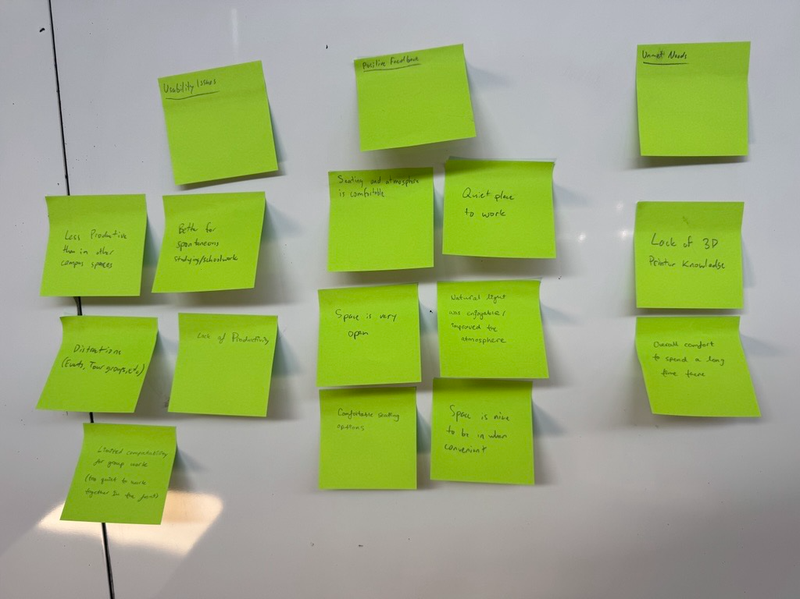

**Part 5: Group Reflection**

**Jack, Sasha, Michael**

**What surprised you in the observations and interviews?**

One of the most surprising insights from our interviews was how differently people perceived the Cove depending on their social and academic needs. While some saw it as a quiet, comfortable space to get work done. Others saw it as to open and distracting for deep focus.

Trinity, for example, liked the Cove for its quiet cubbies but prepared the business buildings empty classrooms for productivity. Frank appreciated the Cove’s social design and openness yet rated his productivity there lower than other spaces like Dierk’s Hall. These contrasting views challenge our assumption that students would either uniformly prefer or avoid the Cove based on its layout.

**What assumptions were challenged?**

The prior expectation going into these interviews was that the COVE was one of the better campus spaces in terms of study spaces. However, our interviews generally came to the conclusion that students prefer to use other spaces to study and/or group work and see the COVE as more of a social space with all the events that happen there. One of the interesting takes that our participants had was that the COVE is too quiet, and that it made them uncomfortable to work there, worrying they would make too much noise or bother others using the space.

**What behaviors or patterns stood out to you?**

A recurring pattern was the Cove’s role as a transitional or convivence-based space. Zach used it only when he had classes nearby, and Trinity stopped going once she moved off campus. Frank echoed this, noting that the Cove used to host more events, which made it a livelier place that promoted community and bonding. The closure of the Cafe also seems to have reduced foot traffic and spontaneous visits. This suggests that the Cove's usage is heavily influenced by proximity, scheduling, and available amenities rather than intrinsic preference.

**Topics/themes identified (in the affinity diagramming)**

Overall, our interviewees noted a lack of productivity in the Cove compared to other study spots on campus. This can be partially attributed to the number of distractions such as tours coming through or disruptions during “passing period”. Additionally, this seemed to be a spot of convenience, not necessarily preference. Generally, people did like the features available (variety of comfortable seating, natural light, makerspace) which boosted the overall atmosphere.

**What would you want to explore more deeply in Part 2 if we were going to extend this research?**

If we could continue our research, it would be beneficial to continue to explore why students find the Cove generally less productive compared to other spaces. For example, *how* can we transform the cove from a space of convenience to a space of desirability? Perhaps we could learn more about students' assumptions/biases by interviewing those who haven't ever used the space. Maybe they view Viets as a whole as just a dorm, and not somewhere they’d go to study for extended periods of time. If we can reshape this potential belief, more people would be able to take advantage of the features available in the Cove.